**DEMO for filestore :**

Create a vm instance . Allow http traffic for vm .

Create filestore instance > file share name , grant access to all clients in the network . Copy ip of nfs . go to ssh of vm and install nfs client .



Mount Fileshare to vm .

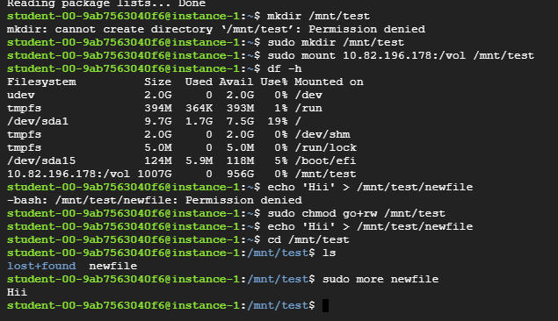

Create directory and Mount nfs to new directory in vm ..



make the file share accessible by changing the permissions so you can do that

with a pseudo.





Create a test file and check whether the file gets created in it or not .